**MANIPULATING DATA WITH DPLYR**

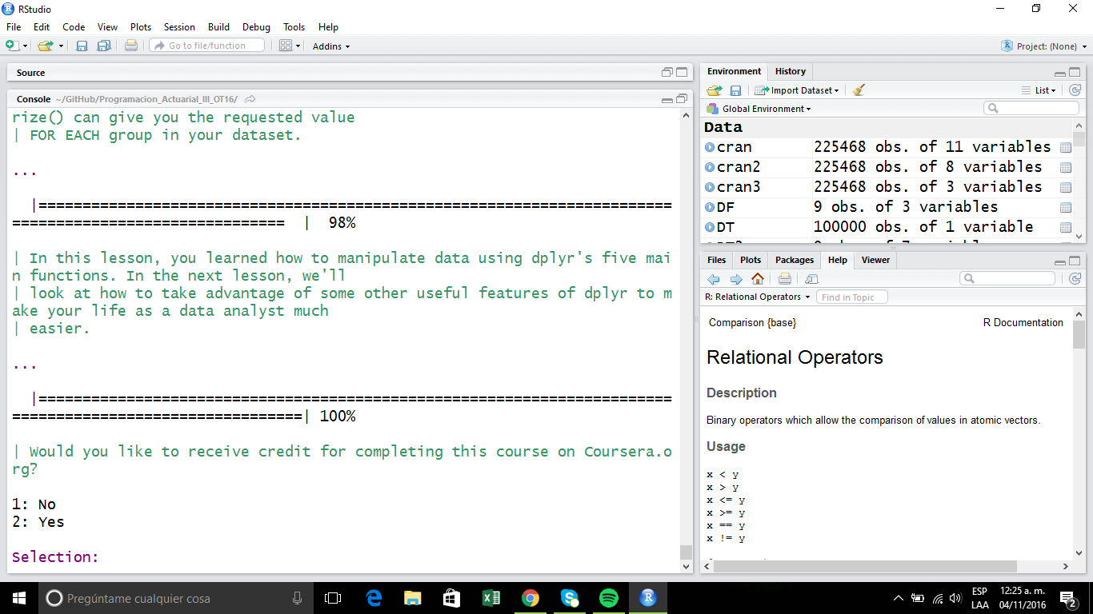

**GROUPING AND CHAINING WITH DPLYR**

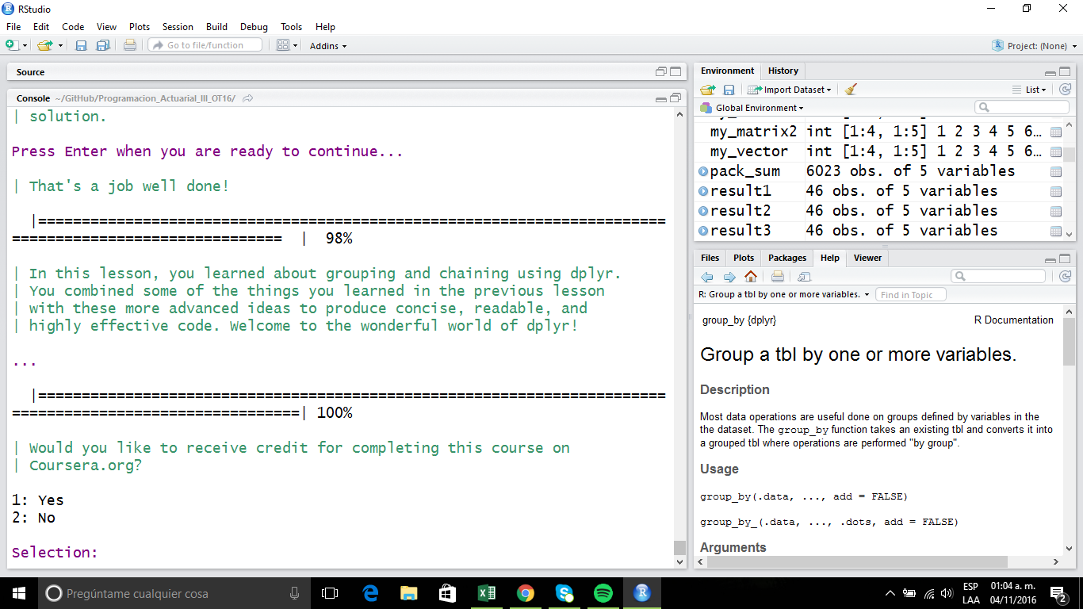

**TIDYING DATA WITH TIDYR**

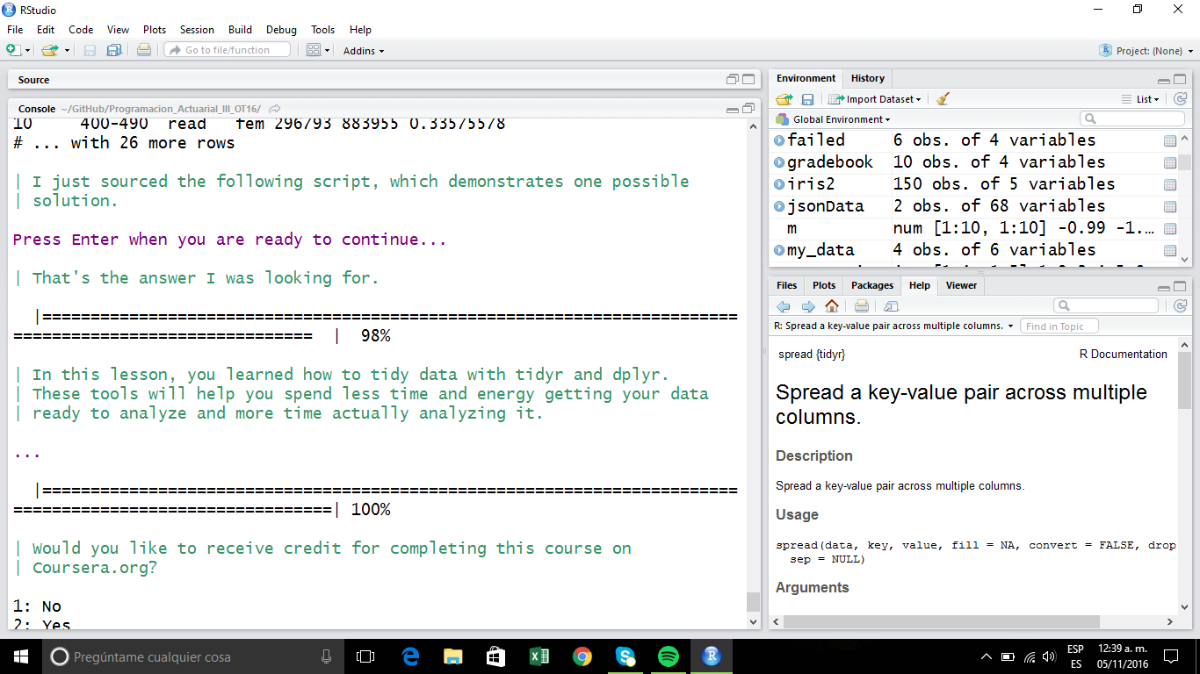

**DATES AND TIMES WITH LUBRIDATE**

